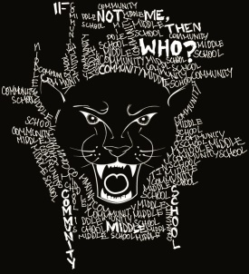* | CMS PTSA – PANTHER WEAR  Fall 2016 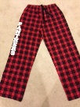
T-Shirts: (Short Sleeve): $12 each – Traditional Design
Black YL_______ AS_______ AM______ AL_______ AXL_______ TOTAL:__________
Red YL_______ AS_______ AM______ AL_______ AXL_______ TOTAL:__________
Gray YL________AS_______ AM_______ AL_______ AXL_______ TOTAL:_________
T-Shirts: (Short Sleeve): $12 each – “If Not Me, Then Who” Design *(see sample above)
Black YL_______ AS_______ AM______ AL_______ AXL_______ TOTAL:__________
Red YL_______ AS_______ AM______ AL_______ AXL_______ TOTAL:__________
Hooded Sweatshirts: $28 each Indicate if you want “If Not Me, The Who” logo on the back: Yes or No
Black YL_______ AS_______ AM______ AL_______ AXL_______ TOTAL:__________
Red YL_______ AS_______ AM______ AL_______ AXL_______ TOTAL:__________
Basketball Mesh Shorts: $15 each
Black YL_______ AS_______ AM______ AL_______ AXL_______ TOTAL:__________
Cheer Shorts: $12 each
Black YL_______ AS_______ AM______ AL_______ AXL_______ TOTAL:__________
Sweatpants: $20 each: We have 2 pant cuff styles. Please circle: A: elastic/gathered or B: straight/open
Black YL_______ AS_______ AM______ AL_______ AXL_______ TOTAL:__________
Flannel “Panther “ Pants: $23 each
Red/Black YL_______ AS_______ AM______ AL_______ AXL_______ TOTAL:_________
~~~~~~~~~~~~~~~~~~~~~~~~~~~~~~~~~~~~~~~~~~~~~~~~~~~~~~~~~~~~~~~~~~~~~~~~~~~~~~~~~~~~~~~~~~~~~~~~~~~~~~~~~~~
Student Name: __________________________________________ Team:__________ TOTAL ENCLOSED: __________
Homeroom Teacher: ____________________________________ Email / Phone: _______________________________________
ORDERS DUE: October 25, 2016. Please return this form with payment (cash or check payable to: “CMS PTSA”). Please put the form and payment in a sealed envelope marked with your child’s name and “CMS Panther Wear”. Questions? Please contact Michele Jaworowski at mpetie12@aol.com.

